Welcome back and in this lesson, I want to talk about CloudFront, which is a content delivery network from AWS.

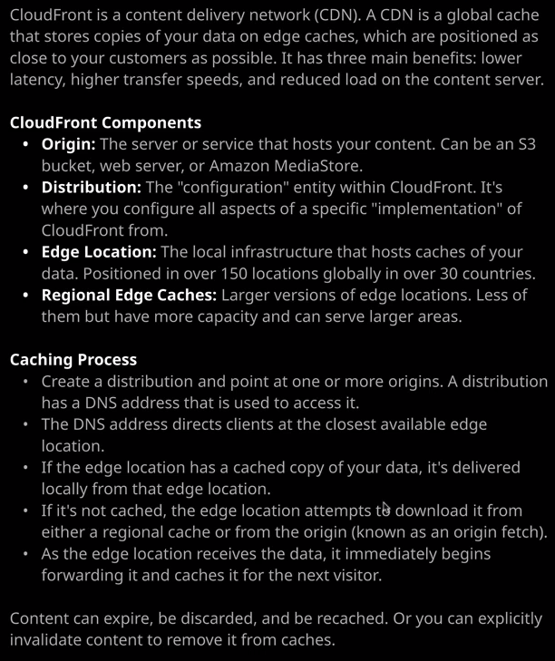

Now, **a content delivery network, or CDN, is a product which takes content which exists in a central location, and it distributes that content globally to local caches and the idea is these caches are located as close to your customers as possible. By having the content closer, it means your customers will get the content delivered faster. So that means higher throughput and lower, more consistent, latency. In addition, load on the server hosting the content is reduced because most of the requests are delivered from the caches rather than the actual server.** CloudFront is one of those products which can be used very simply, but it's also a really complex product. For the Solutions Architect Associate exam, knowledge of the architecture, the basic features, and how to use CloudFront is enough.

So let's step through the basic concepts first and while I'm doing that, I'll actually implement CloudFront to help you get some practical exposure. **Now, all CloudFront distributions begin with an origin and an origin is the server or service that hosts your content. It could be an S3 bucket, a web server, or even other AWS services such as Amazon Media Store. Origins need to be accessible on the internet, either using an AWS public endpoints service such as S3, or web servers, which have a public IP address, if you want to use your own custom origin.**

//Created a public bucket and uploaded content.   
Now, I'm going to go ahead and create an S3 origin to demonstrate in this lesson. So I'm going to move across to S3. I'm going to create a bucket. I'm going to name the bucket something simple, like ac-globalcats. This is going to be a global demonstration, and it needs to include cats. So ac-globalcats and as always, I'll pick the North Virginia region. So U.S. East North Virginia. So I'm going to go ahead and accept the rest of the defaults, the exception being that I'm going to untick block all public access because we'll be using this as a static website. So I'll untick that, accept the rest of the defaults, and go ahead and create the bucket. Now once I've got this bucket, I'll need to upload some sample objects. I'll go ahead and do that. I'll click on "Upload" and then add files. Now inside the storage and content delivery folder and then inside CloudFront I've got a folder called Cloudfront_architecture and this contains some sample objects that I'll be using for this lesson. So I'm going to go ahead and select all of those objects, click on "Open," click "Next," "Next" again, "Next" again to upload them into the bucket.

Now next I want this to act as a //**static website so I'm going to go ahead and enable that**. I'll select "Properties," "Static website hosting," "use this bucket to host a static website," and then for both the index document and the error document I'm just going to put in index.html just to keep things simple. So index .html in both of those boxes. Now lastly, as you've learned about in previous lessons, we'll need **to update the //bucket policy in order to allow all these objects to be publicly accessible.** So I'll click on "Permissions," "Bucket Policy," and then our paste in a sample bucket policy. Now this is just a generic bucket policy that I've updated to allow public read access to all of the objects inside the ac-globalcats bucket. So if you are following along with this in your own environment, you will, of course, need to update this bucket name. But that looks good, I'm good to go. I'm going to go ahead and click on "Save." Now at this point, just to verify everything's working. I'm going to copy this bucket endpoint into my clipboard and then open it in a new tab and there we go. We've got a suitable website complete with an English, Dutch, American and Canadian cat. So this is an ideal website that we can use to implement a global content delivery network. Okay, **so that's the origin configured and the next step for configuring a CloudFront implementation is to configure the distribution, and the distribution is essentially the configuration entity within CloudFront.** **It's where you configure all of the specific options for a given deployment.**

So that's what we'll do next. So I'm going to move across to the AWS console and locate the CloudFront console, which I'll go ahead and open. Once I'm there, I'm going to go ahead and click on "Create Distribution." **Now distributions within CloudFront come in two different types. We've got web distributions and RTMP distributions.**

Now web distributions are by far the most common type, and **they are used to speed up content delivery for any static or dynamic content that you might load in a web browser. For example, HTML files style sheets, various different web scripting languages such as PHP, or media files that are audio, video or pictures. Essentially, a web distribution is used to distribute media files using HTTP or HTTPS.**

**RTMP is used whenever you want to speed up the distribution using Adobe's Flash Media Server RTMP protocol**. So if you face any questions in the exam, **which do mention the Adobe Flash Media Server RTMP protocol then this is the option that you need to pick.**

For this example, I'm going to go ahead and create a web distribution, so I'm going to click on the "Get Started" button beneath web distribution. Now there are a lot of options that you can set when you're creating or modifying a CloudFront distribution. A lot of these aren't relevant from a Solutions Architect Associate Exam perspective or if you're just looking to deploy a simple CloudFront implementation but I do want to draw attention to a number of important ones. **The first is the origin domain name and this is how you point a CloudFront distribution at a particular origin. Remember, I've just created an S3 bucket and configured it as a static website. So I want to point this at the S3 bucket as the origin.** So I'm going to click in there and then pick the ac-globalcats.s3.amazonaws.com S3 bucket. **Origin path allows you to use either the whole bucket or part of a bucket.** So if we admit to set anything here then it uses the entire bucket but if we do want to point this distribution at a particular folder, we can use the origin path to do that. **The viewer protocol policy defines the protocol that's used between the viewer, so that's the customer accessing your CloudFront distribution, and your edge locations which I'm going to talk about momentarily.** At this point, it's worth just talking about these additional terms.

So we've already covered origin and distribution. **The edge location is the local infrastructure the AWS have created globally that actually locally hosts caches of your data. So these are positioned in over 150 locations globally in over 30 countries on this is expanding all the time. So essentially, when you create a distribution inside CloudFront, you deploy that distribution to a number of edge locations and one of the options that I do want to talk about is the price class.** So if you just scroll down on dropdown in this price class dropdown, we can deploy this distribution i.e. we can configure this distribution to operate in either only the U.S., Canada, and Europe locations. The U.S. Canada, and Europe, plus Asia, Middle East, and Africa or we can deploy it to all the edge locations. **Now the more edge locations that we use, the more expensive CloudFront is but of course, the better the performance that your customers get because content is distributed to those edge locations, which are going to be closer to them geographically.**

So for this demonstration, I'm going to go ahead and use all of the available edge locations, and that's actually the recommended approach because it ensures the best performance. I'm going to talk about a lot of these other options in a minute because I want to start getting this distribution deployed because it can take anywhere up to 45 minutes. I'm just going to skip past a number of these and just draw your attention to the **default root object. So CloudFront distributions point to an origin and when you browse to the CloudFront distribution, you can browse to that using a DNS name a cname that's specific for that CloudFront distribution. Now, if you don't specify a document, so if you don't specify index.html or truffle.jpg then what you want is the distribution to look at a default root object and generally, this is going to be index.html**. If I browse this CloudFront distribution and don't use a document then it's going to access index.html on our S3 bucket. So I'm going to set that to index.html and go ahead and create the distribution. Now, what's happening now is the distribution configuration is being deployed to all of the edge locations globally. This could take anywhere up to 45 minutes and this goes for both creating the distribution as well as updating its configuration.